Twitch II – Satin, Straight
From its patented pass-through lock bar design to the assisted opening technology, the SOG Twitch series is the next generation of the classic lockback design. Invented by Spencer Frazer, the Twitch is a 21st century lock back featuring modern construction and technology on the simple, but time-tested lockback folder.

Implement with SOG Assisted Technology (S.A.T. ™), the Twitch is extremely quick to open with either hand using the double thumb studs or kick on the back. Its full metal construction is durable and sturdy. The clip can be used for low-carry or securing dollar bills and cards. Incorporated into the design is versatile safety lock that helps insure the blade will not open while being carried or close unexpectedly while in use. The SOG Twitch series is a great EDC with a variety of options to choose from.

Key Selling Features:
- Quick one-handed opening featuring SOG Assisted Technology (SAT) w/ double thumb studs and kick
- 2.6-inch satin finished straight edge AUS-8 stainless steel blade
- Graphite colored hard anodized 6061-T6 aluminum handle
- Removable pocket clip
- Overall length: 6.2-inches, Weight: 2.6-ounces, Lifetime Warranty

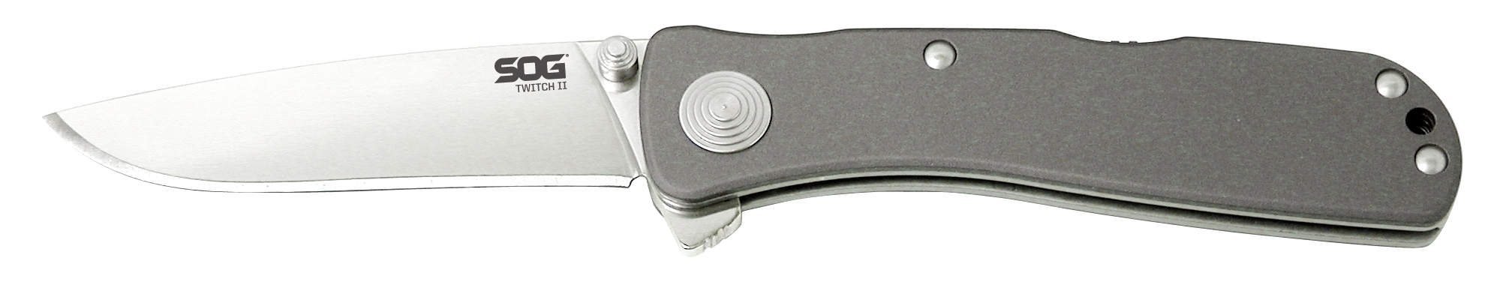
FINISH SATIN POLISHED
BLADE SHAPE DROP POINT
EDGE TYPE STRAIGHT
BLADE STEEL TYPE AUS-8
HANDLE MATERIAL ANODIZED ALUMINUM 6061-T6
HARDNESS RC. 57-58
PRODUCT WEIGHT 2.6 OZ
BLADE LENGTH 2.65”
CLOSED LENGTH 3.55”
OVERALL LENGTH 6.2”
MODEL NUMBER TWI8-CP
UPC 729857994552

