Vulcan Mini – Satin, Tanto
Since 1959, the M61 Vulcan and its derivatives is a 20mm 6-barrel Gatling-style rotary cannon that has been in service in many United States military aircraft through several wars. It fires standard M50 ammunition at 6,000 rounds per minute and is integral part of the armament of modern fighters such as the F-15, F-18, and F-16.

Built upon the M61 Vulcan’s reputation of speed, power, and versatility, the SOG Vulcan is also formidable with a powerful strength of construction. There is nothing weak about the Vulcan. For instance, our patented Arc-Lock™ can hold over 1000 lbs. of force. The full steel liners encased in glass reinforced nylon (GRN) handles give the knife rigidity and durability. The blade is a full .125" thick with tanto shape and includes a double thumb stud and kick for quick, ambidextrous deployment and use. Combining the usability and construction of the knife with a durable VG-10 stainless steel blade make this folder a great addition to the Vulcan name.

Key Selling Features:
- Easy one-hand opening and ambidextrous Arc-Lock
- 3.5-inch satin polished straight edged san mai VG-10 stainless steel blade
- Durable and rugged black glass-reinforced nylon handle with stainless steel liners
- Low-carry reversible pocket clip
- Overall length: 7.35-inches, Weight: 3.4-ounces, Lifetime Warranty

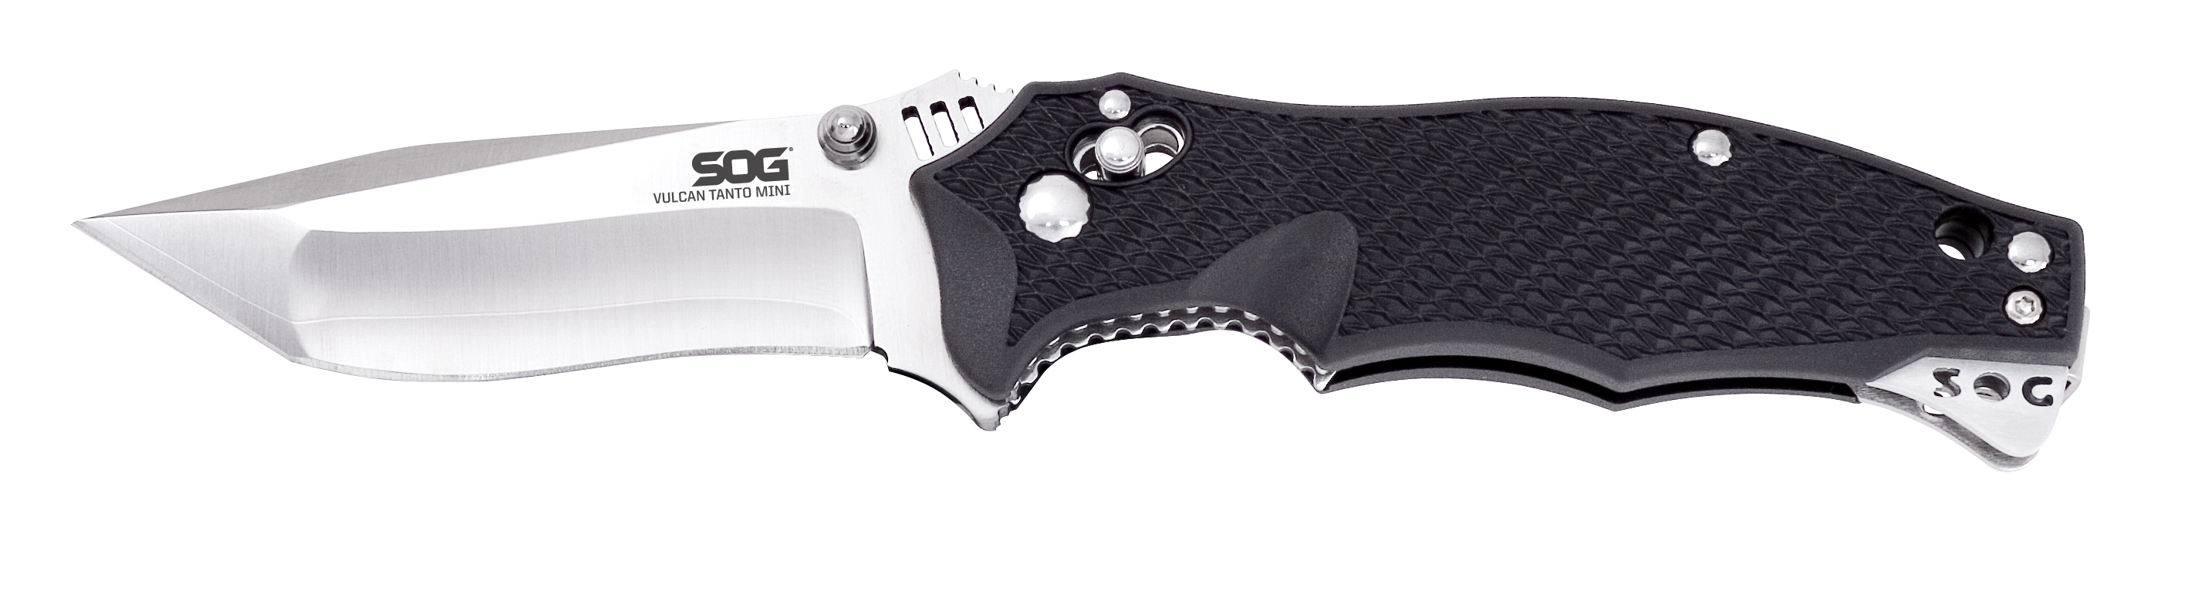
FINISH SATIN POLISHED
BLADE SHAPE TANTO
EDGE TYPE STRAIGHT
BLADE STEEL TYPE SAN MAI VG-10
HANDLE MATERIAL GLASS-REINFORCED NYLON (GRN) / STAINLESS STEEL LINERS
HARDNESS RC. 59-60
PRODUCT WEIGHT 3.4 OZ
BLADE LENGTH 3.0”
CLOSED LENGTH 4.35”
OVERALL LENGTH 7.35”
MODEL NUMBER VL-04
UPC 729857991261

