Visionary II
The SOG Visionary II features the same spectacular blade shape as the Spec Elite, with the handle of a Mini X-Ray Vision. The end result is a great knife in a small package.

People with big and small hands will find the Visionary II a pleasure to hold and carry. It has a finely textured glass-reinforced nylon (GRN) handle that is both lightweight and ergonomic. Its 3.75-inch blade with slightly curved straight edge opens quickly and smoothly via SOG's Arc-Lock™. The high-quality VG-10 stainless steel blade can be used daily while maintaining durability. Its size and weight make the Visionary II a great tactical performance folder.

Key Selling Features:
- Easy one-hand opening and ambidextrous Arc-Lock
- 3.75-inch black TiNi coated straight edged VG-10 stainless steel blade
- Durable and rugged black glass-reinforced nylon handle with stainless steel liners
- Low carry reversible bayonet pocket clip
- Overall length: 8.37-inches, Weight: 4.3-ounces, Lifetime Warranty

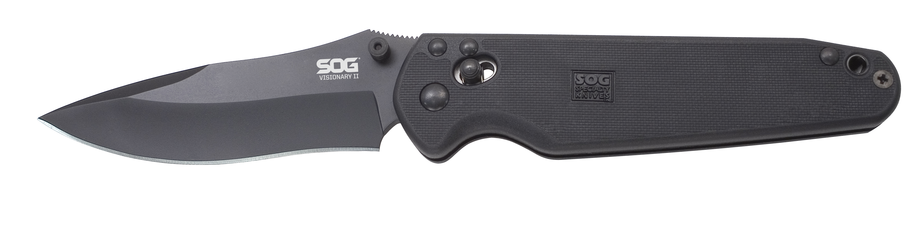
FINISH HARDCASED BLACK TINI
BLADE SHAPE DROP POINT
EDGE TYPE STRAIGHT
BLADE STEEL TYPE VG-10
HANDLE MATERIAL GLASS-REINFORCED NYLON (GRN) / STAINLESS STEEL LINERS
HARDNESS RC. 59-60
PRODUCT WEIGHT 4.3 OZ
BLADE LENGTH 3.75”
CLOSED LENGTH 4.62”
OVERALL LENGTH 8.37”
MODEL NUMBER VS-02
UPC 729857991186

