Visionary I
The SOG Visionary I features the same spectacular blade shape as the Spec Elite, with the handle of a Mini X-Ray Vision. The end result is a great knife in a small package.

People with big and small hands will find the Visionary I a pleasure to hold and carry. It has a finely textured glass-reinforced nylon (GRN) handle that is both lightweight and ergonomic. Its 3-inch blade with slightly curved straight edge opens quickly and smoothly via SOG's Arc-Lock™. The high-quality VG-10 stainless steel blade can be used daily while maintaining durability. Its size and weight make the Visionary I a great EDC.

Key Selling Features:
- Easy one-hand opening and ambidextrous Arc-Lock
- 3-inch black TiNi coated straight edged VG-10 stainless steel blade
- Durable and rugged black glass-reinforced nylon handle with stainless steel liners
- Low carry reversible bayonet pocket clip
- Overall length: 7-inches, Weight: 3-ounces, Lifetime Warranty

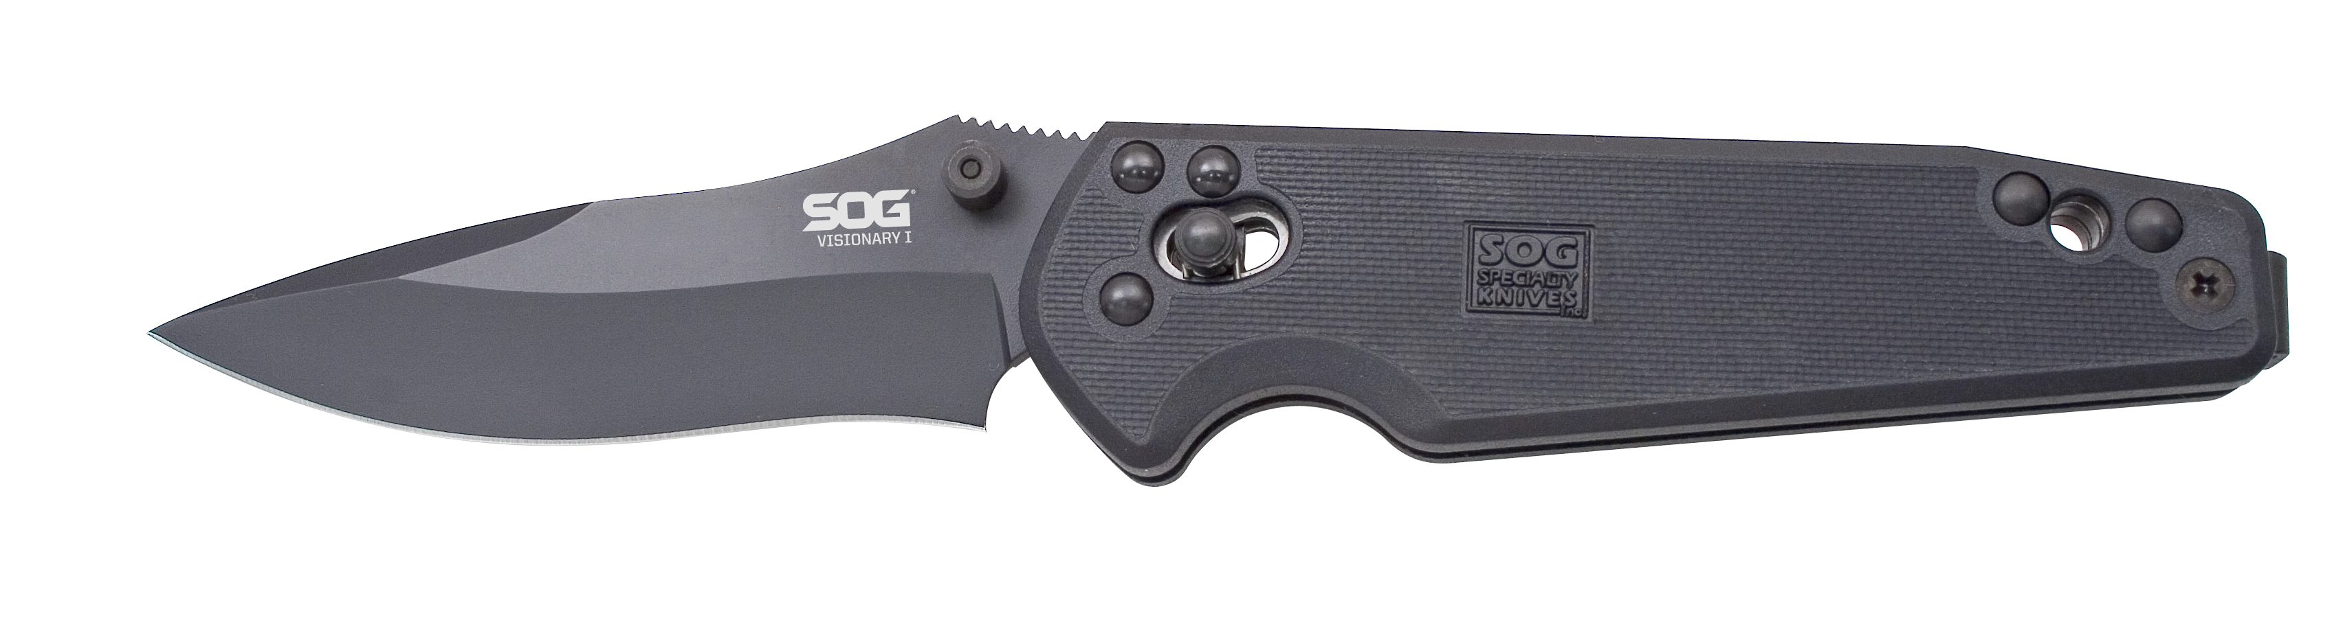
FINISH HARDCASED BLACK TINI
BLADE SHAPE DROP POINT
EDGE TYPE STRAIGHT
BLADE STEEL TYPE VG-10
HANDLE MATERIAL GLASS-REINFORCED NYLON (GRN) / STAINLESS STEEL LINERS
HARDNESS RC. 59-60
PRODUCT WEIGHT 3.0 OZ
BLADE LENGTH 3.0”
CLOSED LENGTH 4.0”
OVERALL LENGTH 7.0”
MODEL NUMBER VS01-CP
UPC 729857994613

